 | Mathematics Essential  Test 9, 2015  Topics – Statistics |  | 47  = %
Total Time: | 45 minutes
Total Reading: | 5 minutes
Total Working: | 25 minutes
Weighting: | 4 of the year.
Equipment Allowed: | Calculator
You must include all working out to receive full marks

CALCULATOR ASSUMED
- (6 marks:1, 1, 1, 1, 1, 1.)
Using the following words complete the sentences below:

Mean Median Mode Range Outlier Quartile Percentile Standard Deviation

a.______________________________ is a measure of spread that describes how far scores are from the mean.
b. The ________________ is the most common or frequent score.
c. An _________________ is a score that is very different from the rest of the data. It can be either much bigger or much smaller than the other scores.
d. The ________________________ is the middle score when the scores are placed in order from smallest to largest.
e. The ____________________ describes the spread of data.
f. The ________________________ is calculated by adding all the scores and diving by the number of scores. It is what most people call the ‘average’.

- (10 marks: 5, 5)
Calculate the mean, median, mode and range of the following:

- Height in cm; 162, 165, 150, 148, 188, 183, 166, 164, 172.
Mean______________________________________________
Median____________________________________________
Mode______________________________________________
Range_____________________________________________

- Cars per household; 1, 1, 2, 3, 5, 0, 0, 2, 2, 1, 2.

Mean______________________________________________
Median____________________________________________
Mode______________________________________________
Range_____________________________________________

- (8 marks:1, 1, 1, 1, 1, 3)

The following stem and leaf plot shows the price of petrol (in cents per litre) at a random selection of metropolitan petrol stations on a Friday.

14 | 3 9 9
15 | 1 2 2 3 5
16 | 5 5 5 9 9
17 | 2 3 5

- How many petrol stations were in the sample?

- What is the highest price for petrol?

- What is the spread of the prices for petrol?

- What is the median price of petrol?

- Is there a mode? If so, what is the mode price of petrol?

- Calculate the mean price of petrol?

- (10 marks: 6, 4)

The following boxplot shows test results for a class:
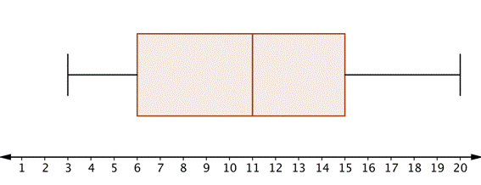

State whether the following questions are true or false:

- The range of the data is 15__________________________________________
- The interquartile range is 9_________________________________________
- About 50% of the scores lie between 6 and 15__________________________
- Fifty percent of the scores are less than 10_____________________________
- About seventy five percent of the scores are greater than 11______________
- About twenty five percent of the scores are greater than 15_______________

There were 30 students who sat the test.
- What was the highest mark?_________________________________________
- What was the lowest mark?__________________________________________
- Approximately how many students score less than 11 out of 20?____________
- Estimate the number of students who scored 13 out of 20._________________

- (5 marks)

Using the following information construct a boxplot

Lowest score = 5, highest score = 19, median = 10, Q₁=8, Q₃=15

- (8 marks)

Draw a box and whisker plot for the following data set:
5, 1, 7, 8, 3, 6, 3, 6, 8, 4

